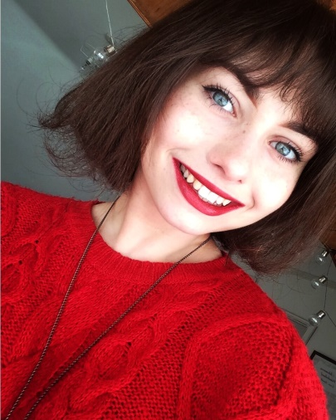 |  | 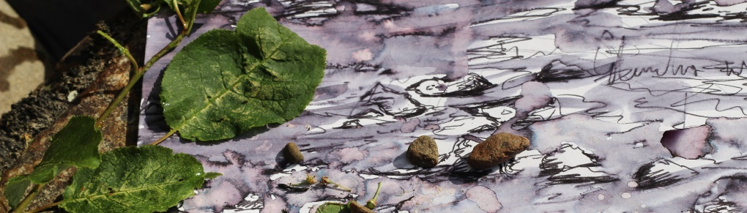  Alice Bootle  Contemporary Artist
About  As a landscape painter, my main source of inspiration is the natural world that surrounds me. My appreciation for landscapes is a combination of childhood nostalgia and the beauty and contemplation I find in nature. I incorporate writing into my paintings, intertwining memories to bring an element of storytelling to the artwork. I also use techniques such as ripping and combining ink and water to create a sense of atmosphere, to draw the audience in and to immerse them in the landscape.  Contact  WESBSITE:  alicebootleart.com  EMAIL:  alicebootleart@gmail.com  FACEBOOK:  Alice Bootle Art  INSTAGRAM:  @alicebootle.art |  | Exhibitions  ‘Beyond The Room’ Bridge House Art Exhibition, An Talla Solais, Ullapool  February 2016  Portfolio Course Exhibition.  The Pagoda, Grantown-on-Spey  May 2017  Exhibition of former Grantown Grammar School students’ artwork.  Inverness UHI HNC Outdoor Exhibition  May 2017  Display of slate work in the Inverness UHI outdoor exhibition space.  Inverness UHI HND Show  May 2018  Exhibited tree triptych ink and water paintings and slate work in the Inverness UHI Gallery.  Dickson’s Suzuki BA Degree Show  May 2019  ‘Childhood Reflections’ ink and water paintings exhibited at Dickson’s showroom, Inverness for BA Degree Show.  WORK EXPERIENCE  Art Workshops  2013-2015  Weekly voluntary work at Carrbridge Active Youth Club providing art and craft workshops to children aged 9-13.  2018  Working with P6-7 children at Abernethy Primary School. Using the theme, Forest Schools as a source of inspiration to develop skills and techniques in sketching and ink and water painting.  Lighting Assistant for Professional Photographer  2016 – present  Working alongside Charne Hawkes of ‘Captivating Photography,’ setting up equipment and organizing lighting and positioning.  Education  SQA Higher  Advanced Higher Art, Higher Photography, English, Music and French.  Higher Education  BA Hons Contemporary Art and Contextualized Practice.

